**Ideation Phase**

**Brainstorm & Idea Prioritization Template**

|  |  |
| --- | --- |
| Date | 10 Oct. 22 |
| Team ID | PNT2022TMID18041 |
| Project Name | Hazardous Area Monitoring For Industrial Plant Powered By IoT |
| Maximum Marks | 4 Marks |

**Brainstorm & Idea Prioritization Template:**

Brainstorming provides a free and open environment that encourages everyone within a team to participate in the creative thinking process that leads to problem solving. Prioritizing volume over value, out-of-the-box ideas are welcome and built upon, and all participants are encouraged to collaborate, helping each other develop a rich amount of creative solutions.

Reference: [Empathy map](https://app.mural.co/t/ibmiot2761/m/ibmiot2761/1664458949086/80d422ed07f2d303d58dd45fefa70e6ea904ee7c?sender=uff9b4eafa40dad65695d9116)

**Step-1: Team Gathering, Collaboration and Select the Problem Statement**

**Step-2: Brainstorm, Idea Listing and Grouping**

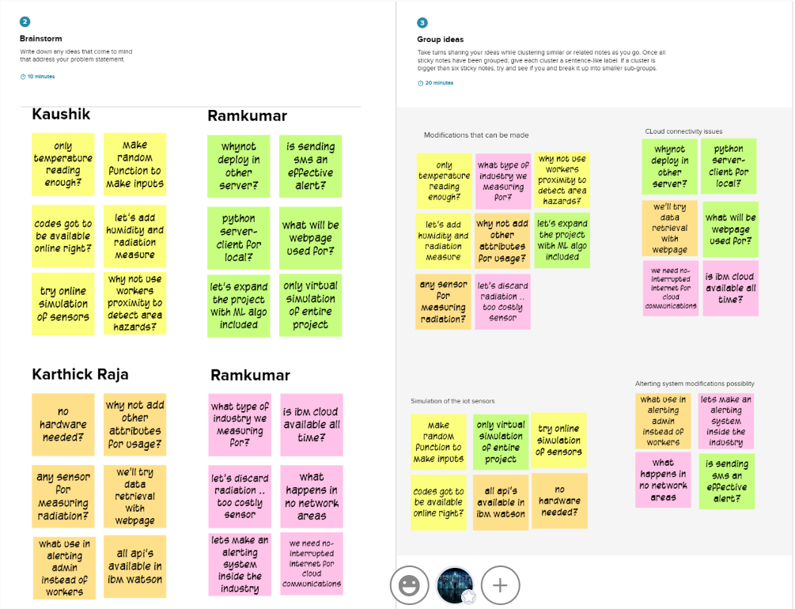

**Step-3: Idea Prioritization**

